**Installation Guide for Graphical User Interface (GUI) for STICCS and TFM combined analysis**

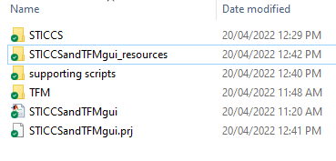This document provides instructions on installation of GUI for STICCS and TFM analysis implemented in Matlab 2022a (Natick, MA). The user will need ideally most recent version Matlab and have Image and Signal Processing toolboxes installed. Older version of Matlab that do not support Maltab App Designer will not be usable as this GUI was designed using App Designer and GUIDE interface in Matlab. Please ensure to download the full package including the gui file STICCSandTFMgui.mlapp, STICCSandTFMgui.prj and supporting folders as shown in fig 1.

**Figure 1: STICCS and TFM GUI analysis folder contents**

Inside ‘Supporting scripts’ folder you will find all the supporting m files and a sub-folder ‘bfmatlab’ containing Open Microscopy Environment (OME) package, used to open czi or other image files. If file ‘bioformats_package.jar’ is missing in this subfolder, please go to following page (https://www.openmicroscopy.org/bio-formats/downloads/) and download the most up to date version of ‘bfmatlab’ folder and unzip it. Please ensure all the contents of ‘STICCS and TFM GUI’ are in a common folder within the home Matlab directory installed on the computer used for analysis. Also, ensure to add all the content of this folder to the

1

2

3

4

**Figure 2: How to add folder with subfolders to path in Matlab.**

Matlab path by clicking on ‘Set Path’ (#1 in Figure 2) and selecting ‘Add with Subfolders’ (#2 in Figure 2). Then select the ‘STICCS and TFM GUI’ so that all the subfolders paths show as in #3 in Figure 2. Click on ‘Save’ and then ‘Close’ (#4 in Figure 4).

Next, proceed by packaging the GUI by opening the STICCSandTFMgui.prj file inside the main folder, within the Matlab session as shown in Figure 3:

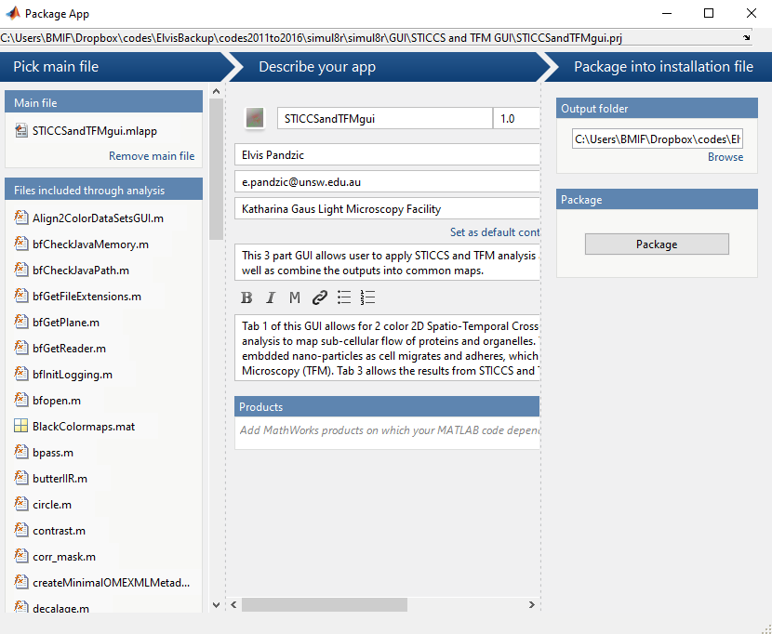 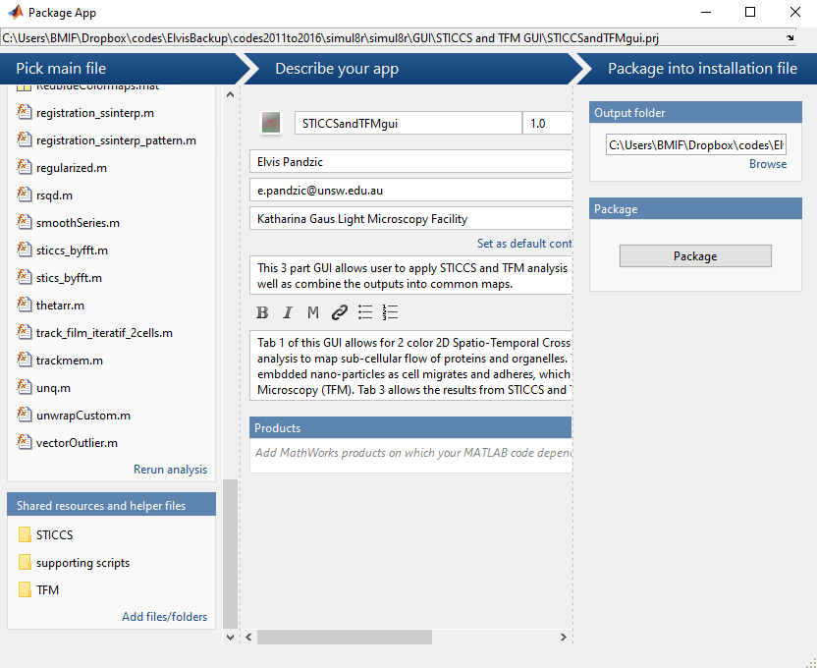

4

3

2

1

**Figure 3: packaging GUI in Matlab using STICCSandTFMgui.prj file.**

Click on ‘Remove main file’ as shown in ‘1’ above and then click on ‘Add main file’ and select STICCSandTFMgui.mlapp file in the folder you have saved on your local Matlab folder. Then click on ‘Add/files/folder’ as shown in ‘2’ above and select the unzipped ‘TFM’, ‘STICCS’ and ‘supporting scripts’ folders on your local folder where you saved all the scripts. Next, ensure all the toolboxes ( Image and Signal Processing) are added as shown in the Figure 3 at ‘3’ and use ‘+’ to add them. Please ensure those toolboxes are added to Matlab during the installation process, as ‘+’ does not install them, only adds them to this GUI. Lastly, click on ‘Package’ as shown in ‘4’ above. The packaging will proceed and when finished it will display at position 4 of Figure 3, ‘Packaging Complete’ (Figure 4a). In the folder where .mlapp and .prj file for this GUI were placed, you will notice a new file STICCSandTFMgui.mlappinstall. Please click on this file and it will open the window as shown in Figure 4b. Click on ‘Install’ and this proceed to add the packaged GUI to the ‘Apps’ tab of Matlab.

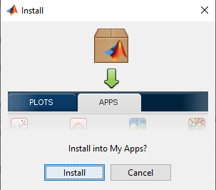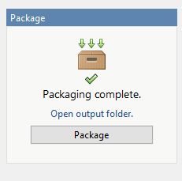

**A**

**B**

**Figure 4: Packaging and Installation of GUI for STICCSandTFMgui analysis.**

Now that GUI is installed, please navigate to Matlab’s ‘Apps’ tab at the top and click on the arrow indicated by ‘1’ below to see all the available Apps, both Matlab built in and custom made ones. In the section ‘My Apps’ you will only have this GUI app installed as shown in ‘2’ in Figure 3 below, but likely not other GUIs in My Apps.

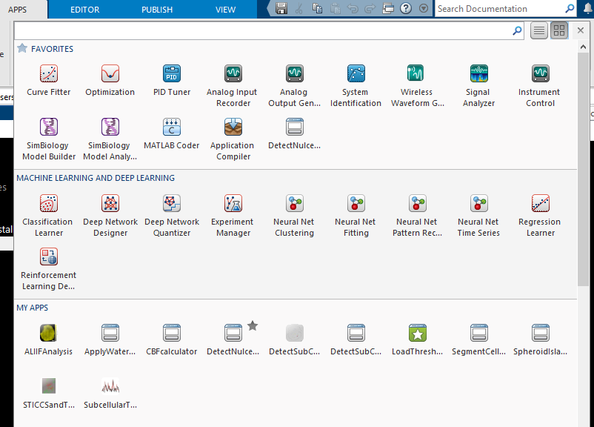

2

1

**Figure 5: Where to find the installed GUI.**

Top open installed GUI, click on the Apps tab as shown in figure 5. Locate installed GUI STICCSandTFMgui and click on it to open it. It will open the menu as shown in figure 6 below.

